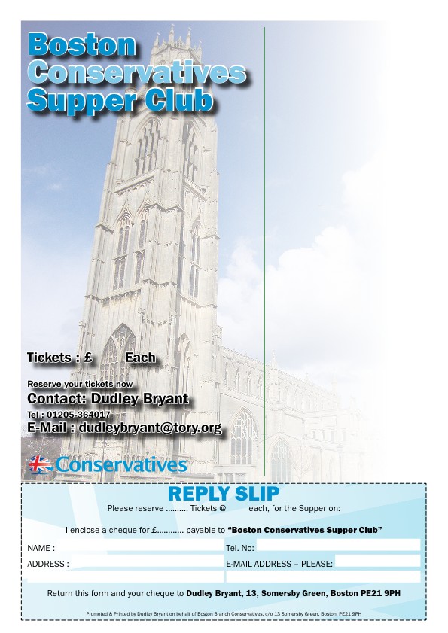
You and your friends
are invited to
Supper Club
On
Friday 15th November 2013 at 7.30pm
**************************
To be held at
Boston & County Club
Parkgate, Boston, PE21 6RL
**************************
R.S.V.P by Friday 8th Nov. 2013
********
Guest Speaker
Mark Simmonds
Member of Parliament for Boston & Skegness
**************************
Supper Menu
Roast Lamb
on a bed of Rosemary Mash,
Meringue Nest with Raspberries
**************************
Forthcoming Events
17 Jan. Emma McClarkin MEP

Friday, 15th November 2013
RSVP by Friday, 8th September 2013

