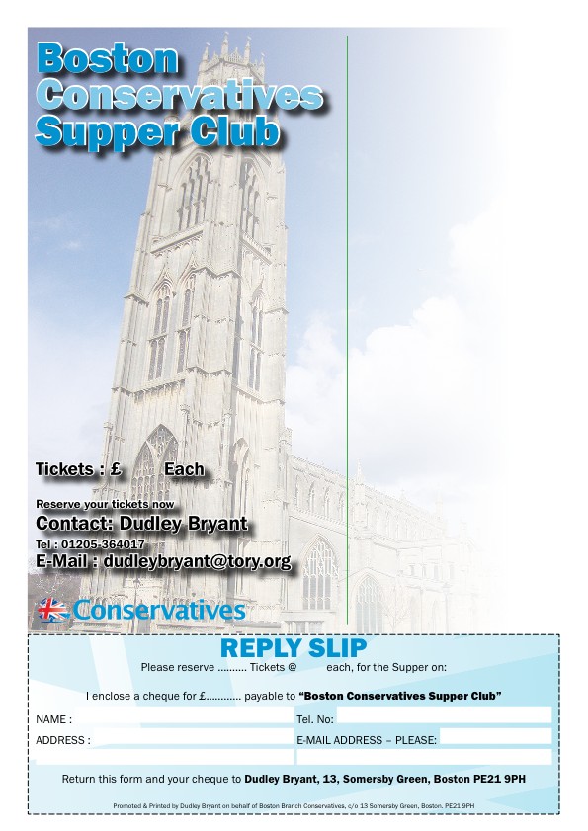
You and your friends are invited to
SUPPER CLUB
Friday 20th November 2015
at 7.30pm
To be held at
Boston & County Club
Parkgate, Boston PE21 6RL
………
RSVP by Friday 13th Nov. 2015
Guest Speaker
Liz Bates
Chief Executive Officer, Heritage Lincolnshire
“Boston’s Heritage & The Heritage Trust in Lincolnshire”
Supper Menu
Turkey with Stuffing, Chipolata & Bacon.
Profiteroles with Chocolate Sauce & Cream
Forthcoming Events
15 January 2016
Andrea Jenkyns MP, Member of Parliament for Morley & Outwood
18 March 2016 : Matt Warman MP
Friday, 20th November 2015
RSVP by Friday, 13th November 2015
£12.50
12.50

