Boston Conservatives Supper Club

You and your friends are invited to Supper Club

7pm Friday 20th November 2026

at Boston & County Club, Parkgate, Boston. PE21 6RL

Guest Speaker
CLAIRE FOSTER
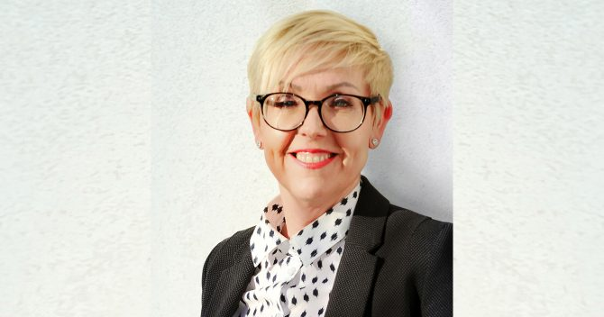

Former Principal & CEO Boston College
“Boston 400”

BOSTON 400 supports the upcoming 400th anniversary of the founding of Boston by shedding light on how individuals from Boston, Lincolnshire, England played a pivotal role in founding the Mass. Bay Company and Boston, Massachusetts.
Although Boston’s 400th Anniversary is more than five years away, BOSTON 400 champions the build-up to it in 2030 by presenting the founding of the Massachusetts Bay Company and stories of immigrants from the town of Boston and other areas of Lincolnshire, England, from 1620 through 1641.

Menu : Boiled Gammon & Mustard Sauce, Apple Crumble served with Custard, Coffee & Mints

Tickets: £25 each RSVP by Friday 13th November 2026
*******************************************************************
SUPPER CLUB BOOKING FORM : 20th November 2026
Please reserve ……………. Tickets at £25 each Total : £ …………..…

NAMES : [1] ……………………………………..…….………….. [2] ……….………………………………………

[ ] I have paid £ ……………… by BACS to “Boston Conservatives Supper Club”
Sort Code : 30-63-47 Account No : 34376268

[ ] I enclose Cheque for £ …………….

- Signed : ……………………………………………… Dated : …………………………………………

PLEASE COMPLETE BOOKING & PAYMENT FORM RETURN BY Email or post AS SOON AS POSSIBLE TO DUDLEY BRYANT
Email : dudleybryant14@gmail.com Post : 13 Somersby Green, Boston. PE21 9PH
Promoted & Printed by Dudley Bryant on behalf of Boston Branch Conservatives c/o Morgan House, 13 Somersby Green, Boston. PE21 9PH

