Boston Conservatives Supper Club
Another enjoyable evening at Boston & County Club.
Less politics and more beer! Emma McClarkin OBE the Chief Executive of the Beer & Pubs Association entertained us about the current difficulties in the hospitality trade
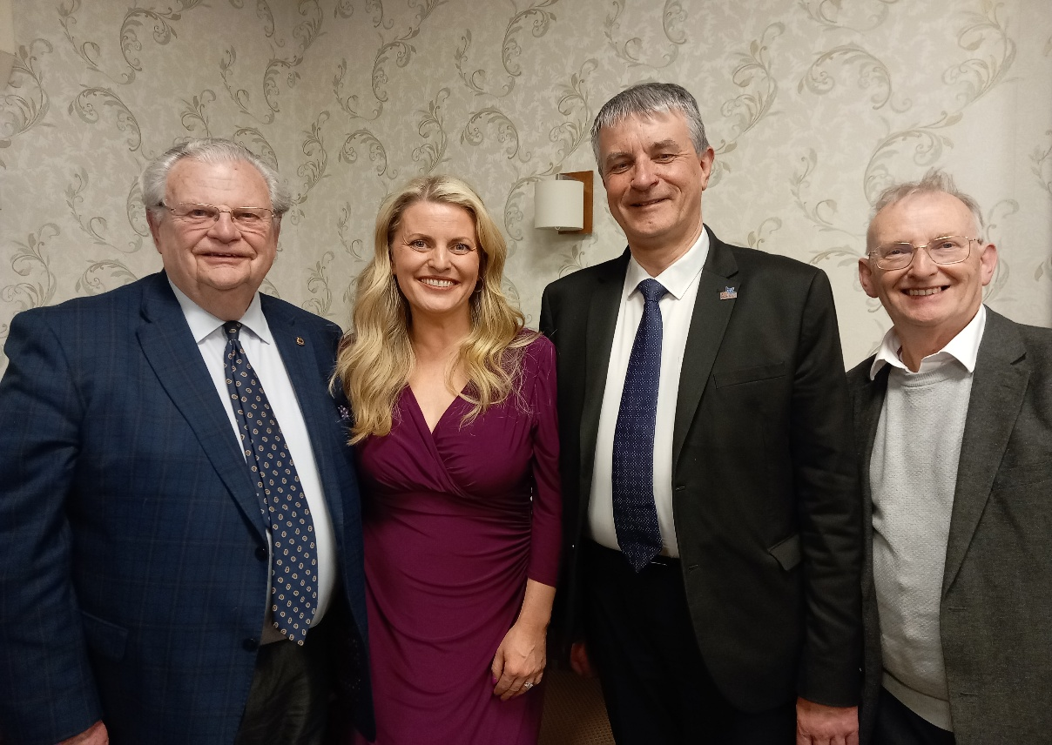
Emma was last here with us on 19th January 2019 when she was our MEP representing the East Midlands. A lot of beer has passed over the bar since then.
A Bachelor of Laws in Business Law she started work as a law clerk and then worked as a government relations executive for the Rugby Football Union.
In May 2009, she was one of five candidates elected to the European Parliament from the East Midlands Region. She was at that time the youngest elected member in the European Parliament.
She was re-elected in 2014 and sat on a number of European Parliament Committees and delegations, including the Committee on International Trade, the Committee on Culture and Education and the Delegation for Relations with the United States.
After Brexit In September 2019 she was appointed as chief executive of the British Beer and Pub Association (BBPA).
In the 2022 Birthday Honours Emma was appointed Officer of the Order of the British Empire (OBE) for services to the hospitality sector, particularly during COVID-19.
Next Supper Club : 18th September
Josh Smith of Next Gen Tories & John Cowpe of Skegness Conservatives and author of a new book “Wider Ownership: A Way Forward for the UK”
Josh Smith, Director of Policy at NextGenTories
Next GenTories are transforming the Conservative Party to win back the support of working age people and secure the future of our Party. Delivering the well-paying jobs, affordable homes and family life everyone should be able to aspire to.

