Boston Conservative Supper Club
The 79th Supper Club was held at Boston & County Club on Friday 20th March
A full house of 70 guests enjoyed a loin of pork supper
followed by a talk from Annunziata Rees-Mogg
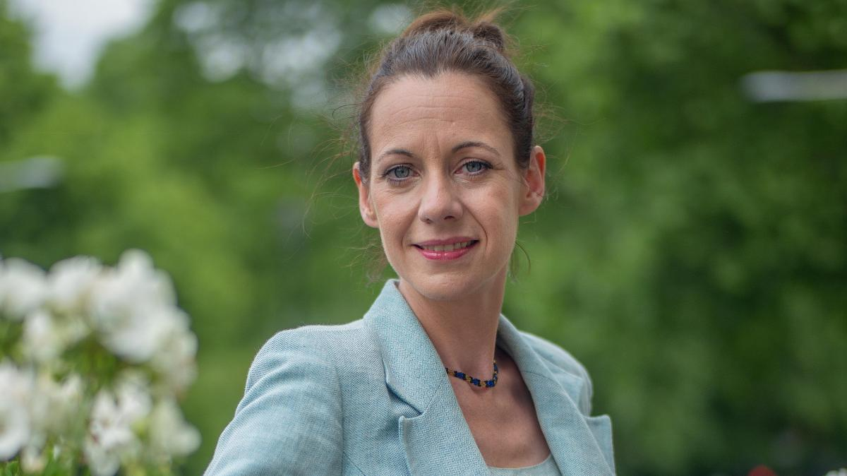

Annunziata talked about current political affairs both locally and nationally giving us a clear view and assessment of Popular Conservatism.
Starmer and Labour are failing us; Reform talk well but don’t have credible solutions to our problems.
NEXT SUPPER CLUB : FRIDAY 15TH MAY 2026
If you would like to attend please contact dudleybryant14@gmail.com

