Boston Conservatives Supper Club

You and your friends are invited to Supper Club

7 pm Friday 15TH MAY 2026

at Boston & County Club, Parkgate, Boston. PE21 6RL

RSVP by Friday 8th May 2026

Guest Speaker

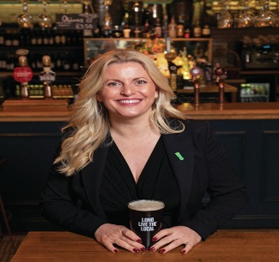

EMMA MCCLARKIN OBE
Chief Executive of the British Beer & Pubs Association

Supper Menu

Fish Pie, Treacle Sponge, Coffee & Mints
*****************************************************************************

BOOKING FORM
Please reserve ……………. Tickets at £25 each : Total : £ …………..…

NAMES : [1] ……………………………………..…….………….. [2] ……….………………………………………

[ ] I have paid £ ……………… by BACS to “Boston Conservatives Supper Club”
Sort Code : 30-63-47 Account No : 34376268

[ ] I enclose Cheque for £ …………….

- Signed : ……………………………………………… Dated : …………………………………………

PLEASE COMPLETE BOOKING & PAYMENT FORM RETURN BY Email or post AS SOON AS POSSIBLE TO DUDLEY BRYANT

Email : dudleybryant14@gmail.com Post : 13 Somersby Green, Boston. PE21 9PH
Promoted & Printed by Dudley Bryant on behalf of Boston Branch Conservatives c/o Morgan House, 13 Somersby Green, Boston. PE21 9PH

