BOSTON CONSERVATIVES SUPPER CLUB

Friday 20th March
Guest Speaker : Annunziata Rees-Mogg
“PopCon” Popular Conservatism
Journalist and former MEP


Friday 15th May
Guest Speaker : Emma McClarkin OBE
CEO British Beer & Pub Association
Former East Midlands MEP
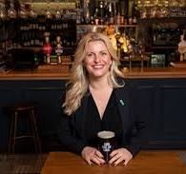

Venue : Boston & County Club, Parkgate, Boston PE21 6RL
Tickets : £25
Further Details Contact : dudleybryant14@gmail.com

