Boston Conservatives Supper Club

You and your friends are invited to Supper Club

7 pm Friday 16th JANUARY 2026

at Boston & County Club, Parkgate, Boston. PE21 6RL

RSVP by Friday 9th January 2026

Guest Speaker

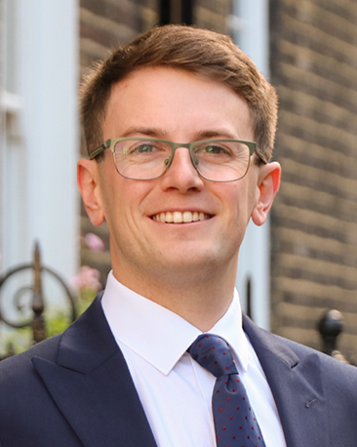

DARWIN FRIEND
Taxpayers’ Alliance

Supper Menu

Boiled Gammon with Parsley Sauce Meringue Nest with Raspberries Coffee & Mints

Tickets: £25 each Book your tickets now

PLEASE COMPLETE THE attached BOOKING & PAYMENT FORM

RETURN BY Email or post AS SOON AS POSSIBLE TO

Email : dudleybryant14@gmail.com

Post : Dudley Bryant, Morgan House, 13 Somersby Green, Boston. PE21 9PH

Promoted & Printed by Dudley Bryant on behalf of Boston Branch Conservatives c/o Morgan House, 13 Somersby Green, Boston. PE21 9PH

