Boston Conservatives Supper Club

Supper Club on Friday 21st November welcomed Guest Speakers Neil Wright
and Martin Fairman at the Boston & County Club. 60 guests enjoyed a supper of Steak & Ale Pie, Spotted Dick & Custard, Coffee & Mints

Martin fairman Neil wright
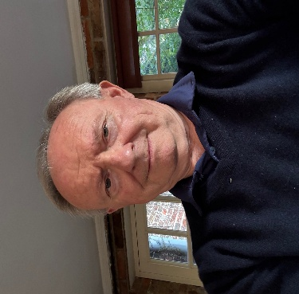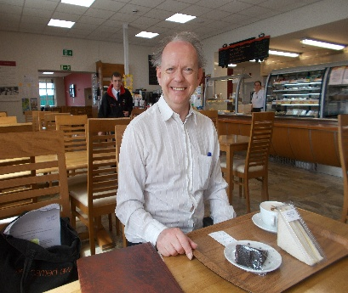
Chairman Well Known
Boston Preservation Trust Local Historian

Our speakers gave a fascinating and factual talk about Fydell House in Boston known as
“The Grandest House in Town”

Neil Wright is a very well-known Boston historian having spent years researching its heritage and perhaps knows more about Boston than anyone else. He gives regular talks and has written numerous books about Boston. He is former Chairman of the Society for Lincolnshire History & Archaeology, is closely involved in the Partnership of Historic Boston’s, linking our Boston with Boston Massachusetts, and a Trustee of Boston Preservation Trust.

He presented a living history of the house with anecdotes about the owners mostly from the Fydell family who were prominent Boston citizens including being our Members of Parliament and important wine merchants.

Martin Fairman is well known as the former Consultant Physician at Pilgrim Hospital for some 30 years and is involved in many elements of local civic life and community and is Chairman of Boston Preservation Trust.

He recounted the story of Boston Preservation Trust from 1935 when a small group of local people purchased the house to save it from being demolished by the council to becoming the home of Pilgrim College and now a community asset being completely refurbished at a cost of some £2.5 million thanks to a Heritage Lottery Fund grant.

Fydell House will re-open in the Spring of 2026 when everybody will be welcome to experience and enjoy the wonderful history and benefits of the Grandest House in Town.

