Boston Conservatives Supper Club

You and your friends are invited to Supper Club

7 pm Friday 21st November 2025

at Boston & County Club, Parkgate, Boston. PE21 6RL

RSVP by Friday 14th November 2025

Guest Speakers

Martin fairman Neil wright
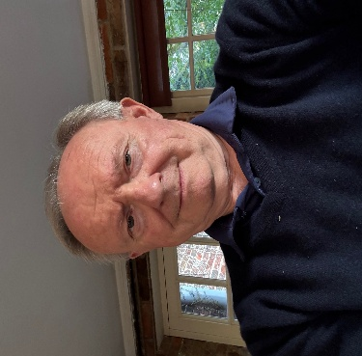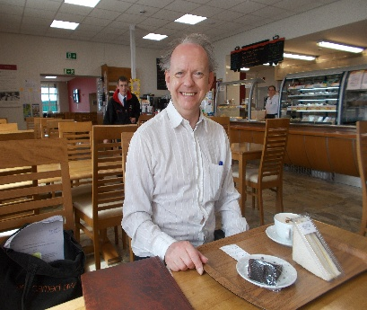
Chairman Well Known
Boston Preservation Trust Local Historian

“Local Boston History & Heritage - Fydell House Past & Future”

Supper Menu

Steak & Ale Pie Spotted Dick & Custard Coffee & Mints

Tickets: £25 each Book your tickets now

PLEASE COMPLETE THE attached BOOKING & PAYMENT FORM

RETURN BY Email or post AS SOON AS POSSIBLE TO

Email : dudleybryant14@gmail.com

Post : Dudley Bryant, Morgan House, 13 Somersby Green, Boston. PE21 9PH

Promoted & Printed by Dudley Bryant on behalf of Boston Branch Conservatives c/o Morgan House, 13 Somersby Green, Boston. PE21 9PH

